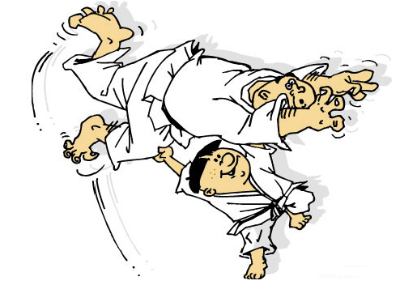
Experience Judo
Beginners Courses 2021
3 x 1hr classes as an intro to Judo

EXPERIENCE the thrills and spills of the dynamic sport of Judo
*Get fit *Learn essential skills for Self-Defence *Gain confidence *Develop core strength

This 3 week course will give you a taste of what Judo is all about, before deciding on joining the UNSW Judo Club, (Biggest Judo Club in Australia)

The course covers: *Basic throwing actions. *Submission techniques *Ground fighting *Skills of falling safely.

There are only 10 participants per class so book early.
Shortly after the 3 week course you will be eligible to sit for a grading for the first belt in Judo – Yellow Belt.
Also RECEIVE a *FREE Judo Suit at completion of the course. Valued at $100
*Once you’ve joined the UNSW Judo Club
When’s it on?

Course 7 Thursday 10 Jun, 17 Jun, 24 Jun 6.30 – 7.30PM East’s PCYC
Course 8 Saturday 19 Jun, 26 Jun, 3 Jul 2.00 – 3.00PM UNSW Gym Women’s Course
Course 9 Thursday 5 Aug, 12 Aug, 19 Aug 6.30 – 7.30PM East’s PCYC
Course 10 Thursday 2 Sep, 9 Sep, 16 Sep 6.30 – 7.30PM East’s PCYC
Course 11 Saturday 18 Sep 25 Sep, 2 Oct 2.00 – 3.00PM UNSW Gym Women’s Course
Course 12 Thursday 14 Oct, 21 Oct, 28 Oct 6.30 – 7.30PM East’s PCYC
Course 13 Thursday 4 Nov, 11 Nov, 18 Nov 6.30 – 7.30PM Easts’s PCYC
Course 14 Thursday 25 Nov, 2 Dec, 9 Dec 6.30 – 7.30PM Easts’s PCYC

Where at? Eastern Suburbs - PCYC 26A Bunnerong Rd Daceyville
Women’s Course - UNSW Fitness & Aquatic Centre High St Kensington

How Much? $60 for students $80 for Public * wear loose clothing and bring a water bottle

Enroll online @ www.unswjudo.net.au

for more info Call: 9385 4725 or Email: w.rosser@unsw.edu.au

